Well, I found a guide to the game. I don’t know who wrote it, but this guy sure isn’t a genius when it comes down to writing! But hey, It’s much better then if I had to write it myself (I haven’t even finished the game for crying out loud)!

Hope it helps!
 |  | IBM-PC VERSION  Realesed in 1990 published by Activision . Developped by Dynamix . under Licence.
Review
Docs & Cheats
Other Stuff
Downloads
This game is particular. In fact the PC scene has got a "personal" version of the Ghostbusters 2 franchise in 1990. While others computers got their GB2 game based on the Amiga version (the Atari the C64...) , for the IBM PC based systems Activision decided to give the project to the Dynamix team. (part of Sierra now , responsible ,among others, of Rise of the Dragon, Hearth of China , and all the Sierra sims)
So what they have done? Well, they have done the best movie conversion compared to other systems. The game follows the movie scripts and offer all the main scenes featured on the Silver Screen, starting from the busting sequence in the court room , passing throgh the Vanhorne Station, ending with the Statue of Liberty and the Vigo confrontation. Oh do not forget the Parkview psychiatric Hospital
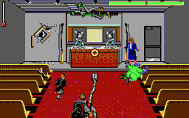 | One of the originality of the game is its non linearity.Let's explain that... The main screen off the game is the HQ where you can decided what to do. You can either get a call and make some money, or visit the Vanhorne station or , lastly try to save the other GBs from parkview when ever you want.You have also to test Slime with Audio clips. Of course there are limitations. If you get all the slime needed but does not have anough money to build the Slime Blower you will go in bankrupcy and the game will be over for exemple so you will need to manage your balance.and remember that you pay damege you do will busting!

The game is ,therefore, presneted in 4 part. The busting sequence where you have to shoot at ghost and put them in traps, the Vanhorne sequnace whe you will try to get Slime for analisys while avoiding ghost and obstacles , a Statue driving sequence and at last but it least an acrobatic sequnace where attached to a rope you most enter the Parkview hospital and recover unfortunate GBs.All thoose scenes give to the game a variety which can hardly been found and increase it's interest and gameplay. Now comes the tecnical stuff which ,Ii have to remember you, is up-to-date to the 1990... | 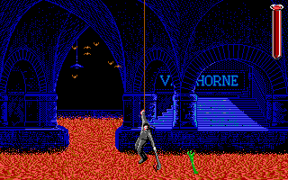

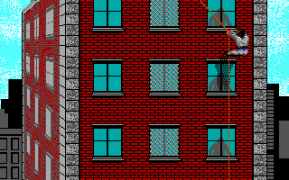 | I was a little disappointed , as far as I remember, when I first played the game on my 386 DX 33 4 Megs of Ram and VGA/MCGA Video Card (a BIG computer for that time. Well , I expected a 256 colors GFX game since in that time they were starting to be more frequent but I've to admit that the GFX is very good for a 16 cols EGA game. Note that the game have digitized pictures from the movie which , in my opinion, are very good for being in 16 colors (Dynamix was top-quality 8 years ago and had with Access Software the best technology for digitised graphics just remember Heart of the China) The only think I will badly criticize is the Prton Beam which is totally different for the real one but hey they have to handle 16 cols palette!

As far sound is concerded I really like the FM Sythesis music. I cannot speak about the SFX 'cause they are mostly from the PC-Speacker. Mostly because the game has digizised Speech from Vigo , Pter and the team.( I remember whenI've played GB2 at midnight when I was 10 and Vigo voice shouting "I vigo , scourge of Carpathia..." affraid me.)  Finally , althoug it had not been a big production for that time this version of GB2 presents some technical features which earn the attention. Add to this a very cool gameplay and variation ... Conclusion : VERY GOOD!! | 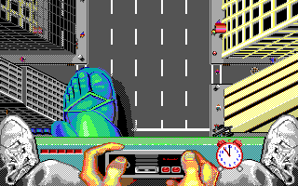

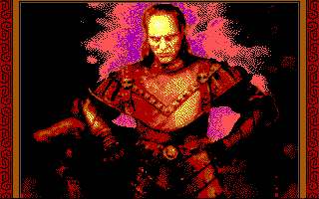 | 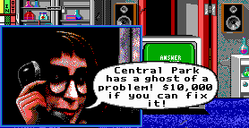

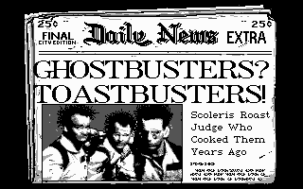 | 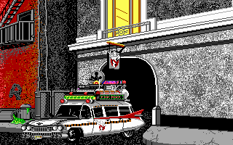

Docs and Cheats
Here follow the GB2 IBM PC Docs based on my expirience of play:

BUSTING GHOSTS:
A Busting Ghost Sequnece is what you will get after the Intro Sequence, that's why it's described firtsly
Controls:
Direction keys or Joy/mouse movement Moves the crosshair
Space Bar/ Joy Fire Button / Left Mouse Button Shoot Proton Streams
Infos
In the Upper Left of The Screen you can see a Thermometer , this indicate you Proton Pack heatness. When it reaches the maximum you can't shoot any more and you will have to wait until in descrease.
Next to the Thermometer blue and/or yellow spheres may appear. This counts how much times you have been hit by Spooks projectile. Get 3 Yellow sphere and the busting is finished and the GB is good for Parkview ( this is not applicable in the first Busting sequence in the Court Room) Get 3 or 6 ( not understodo yet completely ...sorry) Blue spheres and you Pack will be as hot as a Vulcano.
In the Upper Center you see a counter with a number decreasing ( it starts from 10,000 or 20,000) this the money you are erning from the bust Actually it acts as a Count Down. Be Careful if with the Stream you damage the environment this number will descrease very quickly. Seems that shooting at the blue (!) Slimer give you 500-1000$ If the conter reach 0 then "Parkview are I come!" - Not Applicable in the Court Room sequnce. However if you fail to catch the Scoleris you will start with a -10,000 in your balance.
On The Upper Right you there is a Green rettangle ( two of them in the Court Room scene one per Scoleri bro). This is the Ghost energy. When the Rettangle becomes completely red the Spook will be sucked in the trap. Note that you should continue to shoot when the Ghost is over the trap until the trap open. Also notice that if not continualy shoot Ghost energy will recover.

THE MAIN SCREEN:
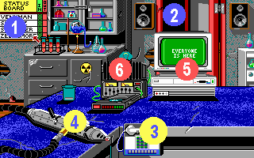
After the Scoleri Bros busting you arrive to the Firehouse HQ which works as the game's main menu. By moving the cursor (with the mosue , joy or keyboard) you can access to the different game parts. As you can see, I've named the various screen locations you can choose with a different number in order to distinguish and describe them.
1. The Status Panel indicates the number of GBs avaible (you number of remaning lifes some sort.). If someone is marked "OUT" you can try to recover him from the Parkview Hospital by clicking on the panel itself. Otherwise Peter will inform you that everyone is OK. I dunno exactly if this is relevant for the final part of the game since you can drive Libby even with 1 GB left.2. The Door let you reach the Vanhorne Station with the purpose of getting additional Mood Slime for testing. You can get sample at time. Peter will warn you.3. The Phone starts a Busting Sequence where you have to catch a ghost and gain as much as money you can. Note that when the phone does not bleep anymore there aren't new calls. Peter as always will warn you.4. The Slime Blower. Appearing only when you succesfully got and tested 3 samples of Mood Slime , The Slime Blower let you drive the Statue of Liberty.5. The Computer displays your balance ( read: "how much money you have" .. if English is not your preffered language) if cursor is moved of it , otherwise it will display descriptin of different HQ part. Note the you will need at least 50,000 $ (50.000 $ for Europeans) to build the Slime Blower or it will be Bankrutpcy.6. The CD Player is used to test Mood Slime. Once you get the Slime for the Vanhorne Station you have to pass it throgh the musical test as in the movie. If you not succeed to select the right song you will have to get more slime again! Do it right 3 time and you are OK. NOTE: One succefully tested Slime sample is sufficent to ride on the Statue of Liberty but you certainly will not have enough Posotive Slime to reach the Museum of Art before 12:00 am.

Getting Slime: The Vanhorne Station
Controls
Directions Move the Ghostbuster
Left mouse button / Joy Fire Button / Space Bar Get Slime ( near the slime River)
Infos
I don't know if filling completely the glass is required but i believe that's is better if you do it.
Also watch out for the hands coming out from the river . If a hand get you move your control and click like a crazy! Got 1 time is good got 2 time is sufficent got 3 time is in 95% cases lethal.
Don't forget to avoid Ghosts ( Slimer or other ghosts) flying around. if you are it a Ghost icon appear in the Top Left of the Screen. I suppose thant 3 of it mean a bath.

Rescuing the Guys at Parkview:

Controls
Directions move the Ghostbuster
Left mouse button / Joy Fire Button / Space Bar Jump on legs to crash Windows or jump to grab the rope once inside a Room
Infos
Inside the room be careful. Avoid medics by moving left or right. Once your are safe you have to jump out of the window AND get the hanging rope . So check the timing. If you fail a medic will grazb you with a net.
If you find a GB ( it's aguy wearing a Green suit) it will be added to the Status panel if you succesfully reach the ECTO-1A. You will not need to grab the rope out of the window if you enter in a room with a GB.
You can also simply come down. The ECTO-1A will bring you back safely the the Firehouse.

The Liberty Statue.
Controls:
Directinal Keys : move you fingers on the Nintendo(tm) Joypad.
It' quite difficult ot explain how to move Libby probably because is not yet clear to me. Let's try:
1. Put your finger to the left, this chooses to move the left foot,
2. Move it up this let the foot advance.
3. Then put the finger on the middle, reset the controls
4. Move the finger to the right to choose the other foot and move it ahead by putting the finger up
5. he down position is not yet clear... Practice it and let me know!
6. Do loop
Infos
Watch out for Cars , when 3 cars are crashe you will loose 1 Slime unit shown in the bottom left of the Screen. Having less Slime means move more slow and you have to reach the museum before 12:00 am. Onthe bottom right there is a clock to keep you informed on the time left.
When the Slime Blower is selected from the main menu you will be able to choose which way the Statue of Liberty will follow for reach the Museum of art. Unfortunately I don't know with which process I've to choose the way, so I do it randomly. if you find out let me know!.

